asFor all the following questions use this database diagram to answer them.

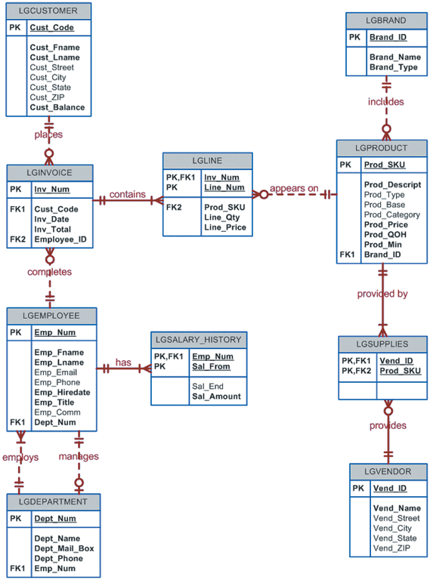

1. Write a query to display the eight departments in the LGDEPARTMENT table sorted by department name.

select *

from LGDEPARTMENT

order by Dept_Name ASC

1. Write a query to display the SKU (stock keeping unit), description, type, base, category and price for all products that have a PROD_BASE of water and a PROD_CATEGORY of Sealer.

Select Prod_SKU,

Prod_Descript,

Prod_Type,

Prod_Base,

Prod_Category,

Prod_Price

From LGPRODUCT

Where PROD_BASE = ‘water’ and PROD_CATEGORY = ‘Sealer’

1. Write a query to display the first name, last name, and email address of employees hired from January 1, 2005 to December 31,2014. Sort the output by last name and then by first name.

Select EMP_FNAME,

EMP_LNAME,

EMP_EMAIL

From LGEMPLOYEE

Where cast(EMP_HIREDATE as date) >= cast(‘2005-01-01’ as date) and cast(EMP_HIREDATE as date) <= cast(‘2014-12-31’ as date)

Order by

EMP_LNAME ASC,

EMP_FNAME ASC

1. Write a query to display the first name, last name, phone number, title, and department number of employees who work in the department 300 and have the title of “CLERK 1”. Sort the output by last name and then by first name.

Select EMP_FNAME,

EMP_LNAME,

EMP_PHONE,

EMP_TITLE,

DEPT_NUM,

From LGEMPLOYEE

Where

DEPT_NUM=300 and EMP_TITLE = ‘CLERK 1’

Order by

EMP_LNAME ASC,

EMP_FNAME ASC

1. Write a query to display the employee number, Last name, first name, salary “from” date, salary end date, and salary amount for employees 83731, 83745, and 84309. Sort the output by the employee number, and salary “from” date.

Select e.EMP_NUM,

e.EMP_LNAME,

e.EMP_FNAME,

s.SAL_FROM,

s.SAL_END,

s.SAL_AMOUNT

From

LGEMPLOYEE e,

LGSALARY_HISTORY s

Where

e.EMP_NUM = s.EMP_NUM and

e.EMP_NUM in (83731, 83745, 84309)

Order by

e.EMP_NUM ASC,

s.SAL_FROM ASC

1. Write a query to display the first name, last name, street, city, state, and zip code of any customer who purchased a Foresters Best brand top coat between July 15, 2015, and July 31, 2015. If a customer purchased more than one such product, display the customer’s information only once in the output. Sort the output by state, last name, and then first name.

Select c.CUST_FNAME,

c.CUST_LNAME,

c.CUST_STREET,

c.CUST_CITY,

c.CUST_STATE,

c.CUST_ZIP,

From LGCUSTOMER as c, LGINVOICE as i, LGLINE as l, LGPRODUCT as p, LGBRAND as b

Where

c.CUST_CODE = i.CUST_CODE and i.INV_NUM = l.INV_NUM and l.PROD_SKU = p.PROD_SKU and p.BRAND_ID=b.BRAND_ID and b.BRAND_NAME = ‘Foresters Best’ and cast(i.INV_DATE as date) >= cast(‘2015-07-15’ as date) and cast(i.INV_DATE as date) <= cast(‘2015-07-31’ as date) and p.PROD_CATEGORY = ‘top coat’

Order by

CUST_STATE ASC,

CUST_LNAME ASC,

CUST_FNAME ASC

1. Write a query to display the employee number, Last name, and email address, title, department name of each employee whose job title ends in the word “ASSOCIATE”. Sort the output by department name, and employee title.

Select e.EMP_NUM,

e.EMP_LNAME,

e.EMP_EMAIL,

e.EMP_TITLE,

d.DEPT_NAME,

From LGEMPLOYEE as e, LGDEPARTMENT as d

Where

e.DEPT_NUM = d.DEPT_NUM and

d.EMP_TITLE like ‘%ASSOCIATE’

Order by

d.DEPT_NAME ASC,

e.EMP_TITLE ASC

1. Write a query to display a brand name and number of products of that brand that are in the database. Sort the output by the brand name.

Select

b.BRAND_NAME,

count(p.PROD_SKU) as Num_Products

From LGBRAND as b,

LGPRODUCT as p

Where b.BRAND_ID = p.BRAND_ID

Group by b.BRAND_NAME

Order by b.BRAND_NAME ASC

1. Write a query to display the number of products in each category that have a water base, sorted by category.

Select PROD_CATEGORY , count(PROD_SKU) as Num_Products

From LGPRODUCT

WHERE PROD_BASE=’water’

GROUP BY PROD_CATEGORY

ORDER BY PROD_CATEGORY ASC

1. Write a query to display the number of products within each base and type combination , sorted by base then by type.

Select count(Prod_SKU) as Num_Products, Prod_Base, Prod_Type

From LGPRODUCT

Group by Prod_Base, Prod_Type

Order by Prod_Base ASC, Prod_Type ASC

1. Write a query to display the total inventory – that is, the sum of all products on hand for each brand ID. Sort the output by brand ID in descending order.

Select b.BRAND_ID, sum(p.PROD_QOH) as All_POH

From LGPRODUCT as p, LGBRAND as b

Where b.BRAND_ID = p.BRAND_ID

Group by b.BRAND_ID

Order by BRAND_ID DESC

1. Write a query to display the brand ID, brand name, and average price of products of each brand. Sort the output by brand name. Results are shown with the average price rounded to two decimal places.

Select b.BRAND_ID, b.BRAND_NAME,round(avg(PROD_PRICE),2) as Avg_Price

From LGBRAND as b, LGPRODUCT as p

Where b.BRAND_ID = p.BRAND_ID

Group by b.BRAND_ID

Order by b.BRAND_NAME ASC

1. Write a query to display the department number and most recent employee hire date for each department. Sort the output by department number.

Select DEPT_NUM, max(EMP_HIREDATE) as Latest_Hire

From LGEMPLOYEE

Group by DEPT_NUM

Order by DEPT_NUM ASC

1. Write a query to display the employee number, first name, last name, and largest salary amount for each employee in department 200. Sort the output by the largest salary in descending order.

Select e.EMP_NUM, e.EMP_FNAME, e.EMP_LNAME, max(s.SAL_AMOUNT) as Largest_Salary, e.DEPT_NUM

From LGEMPLOYEE as e, LGSALARY_HISTORY as s

Where e.EMP_NUM = s.EMP_NUM and e.DEPT_NUM = 200

Group by e.EMP_NUM

Order by Largest_Salary DESC

1. Write a query to display the customer code, first name, last name, and sum of all invoice totals for customers with cumulative invoice totals greater than $1500. Sort the output by the sum of invoice total in descending order.

Select c.CUST_CODE, c.CUST_FNAME, c.CUST_LNAME, sum(i.INV_TOTAL) as Cumu_Inv_Totals

From LGCUSTOMER as c, LGINVOICE as I

Where c.CUST_CODE= i.CUST_CODE

Group by c.CUST_CODE

Having Cumu_Inv_Totals > 1500

Order by Cumu_Inv_Totals DESC

1. Write a query to display the department number, department name, department phone number, employee number and last name of each department manager. Sort the output by department name.

Select d.Dept_Num, d.Dept_Name, d.Dept_Phone, e.Emp_Num, e.Lname

From LGEMPLOYEE as e, LGDEPARTMENT as d

Where e.Emp_Num = d.Emp_Num and e.Emp_Title like ‘%MANAGER%’

Order by d.Dept_Name ASC

1. Write a query to display the vendor id, vendor name, brand name, and number of products in each brand, supplied by each vendor. Sort the output by vendor name and then by brand name.

Select v.Vend_ID, v.Vendor_Name, b.Brand_Name, Count(p.Prod_SKU) as Num_Products

From LGBRAND as b, LGPRODUCT as p, LGSUPPLIES as s, LGVENDOR as v

Where

b.BRAND_ID = p.BRAND_ID and

p.PROD_SKU = s.PROD_SKU and

p.VEND_ID = v.VEND_ID

Group by b.BRAND_ID, v.VEND_ID

Order by v.Vend_Name ASC,

b.Brand_Name ASC

1. Write a query to display the employee number, last name, first name, and sum of incoive totals for all employees who completed an invoice. Sort the output by employee last name, and then by first name.

Select e.Emp_Num, e.Emp_Lname, e.Emp_Fname, sum(i.Inv_Total)

From LGEMPLOYEE as e, LGINVOICE as I

Where e.Emp_Num = i.Employee_ID

Group by e.Emp_Num

Order by e.Emp_Lname ASC,

e.Emp_Fname ASC

1. Write a query to display the largest average product price of any brand.

Select max(Avg_Price) as Largest_Avg_Price

From (

Select p.Brand_Id, avg(p.Prod_price) as Avg_Price

From LGPRODUCT as p

Group by BRAND_ID)

1. Write a query to display the brand ID, brand name, brand type, and average price of products for the brand that has the largest average product price.

Select s.Brand_Name, s.Brand_ID, s.Brand_Type, max(s.Avg_Price) as Largest_Avg_Price

From (

Select b.Brand_Name, b.Brand_ID, b.Brand_Type, avg(p.Prod_price) as Avg_Price

From LGPRODUCT as p, LGBRAND as b

Group by p.BRAND_ID) as s

Group by s.brand_ID